Blaise A Johnson

July 27, 2025

Assignment 9.2

Tutorial

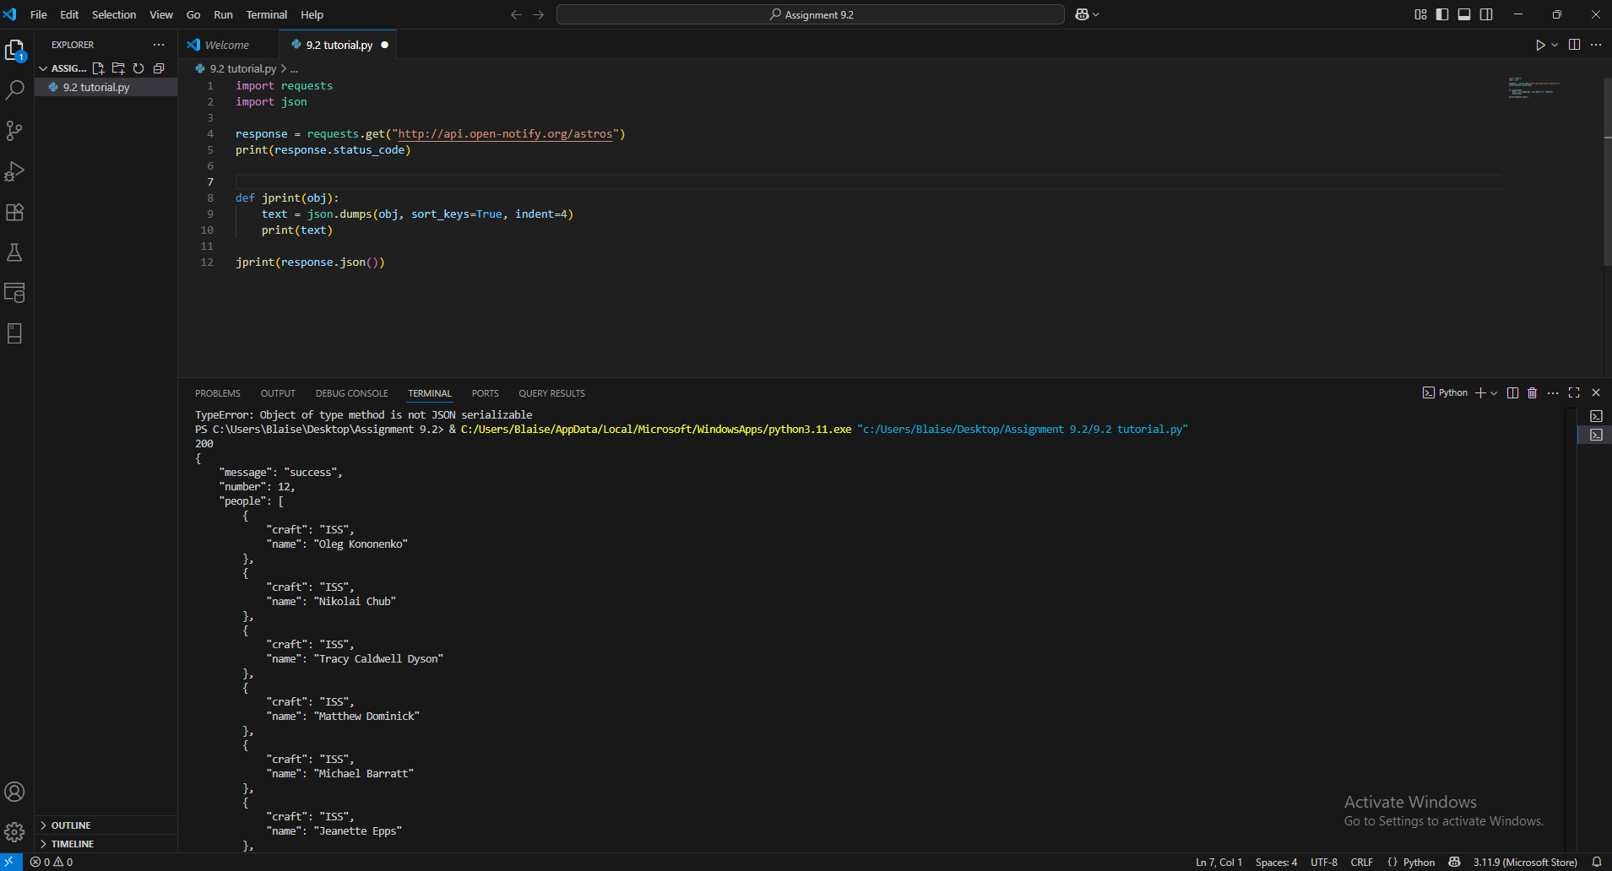

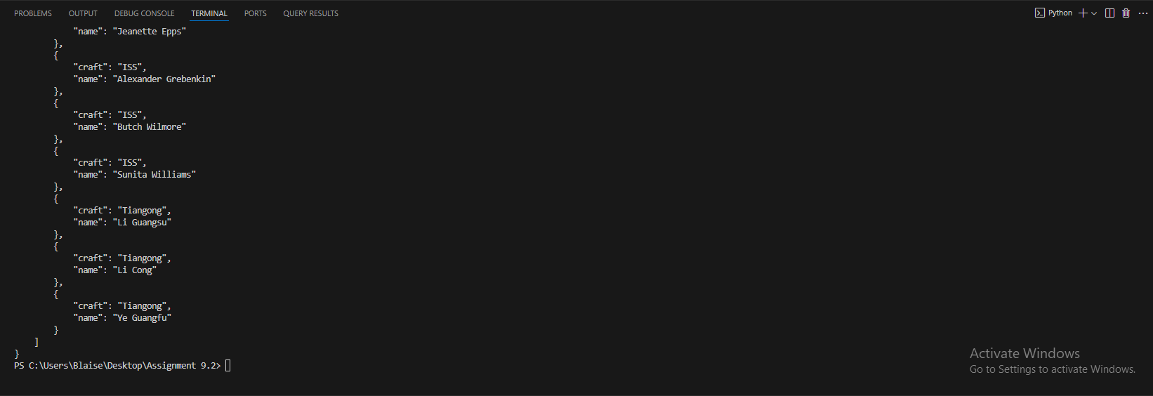

Pokémon TCG Api

Unformatted

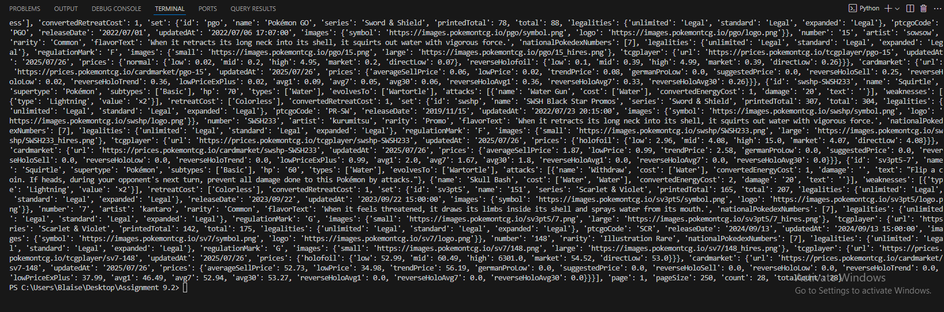

Formatted

